Alexandra M. Overby, PhD, NBCT
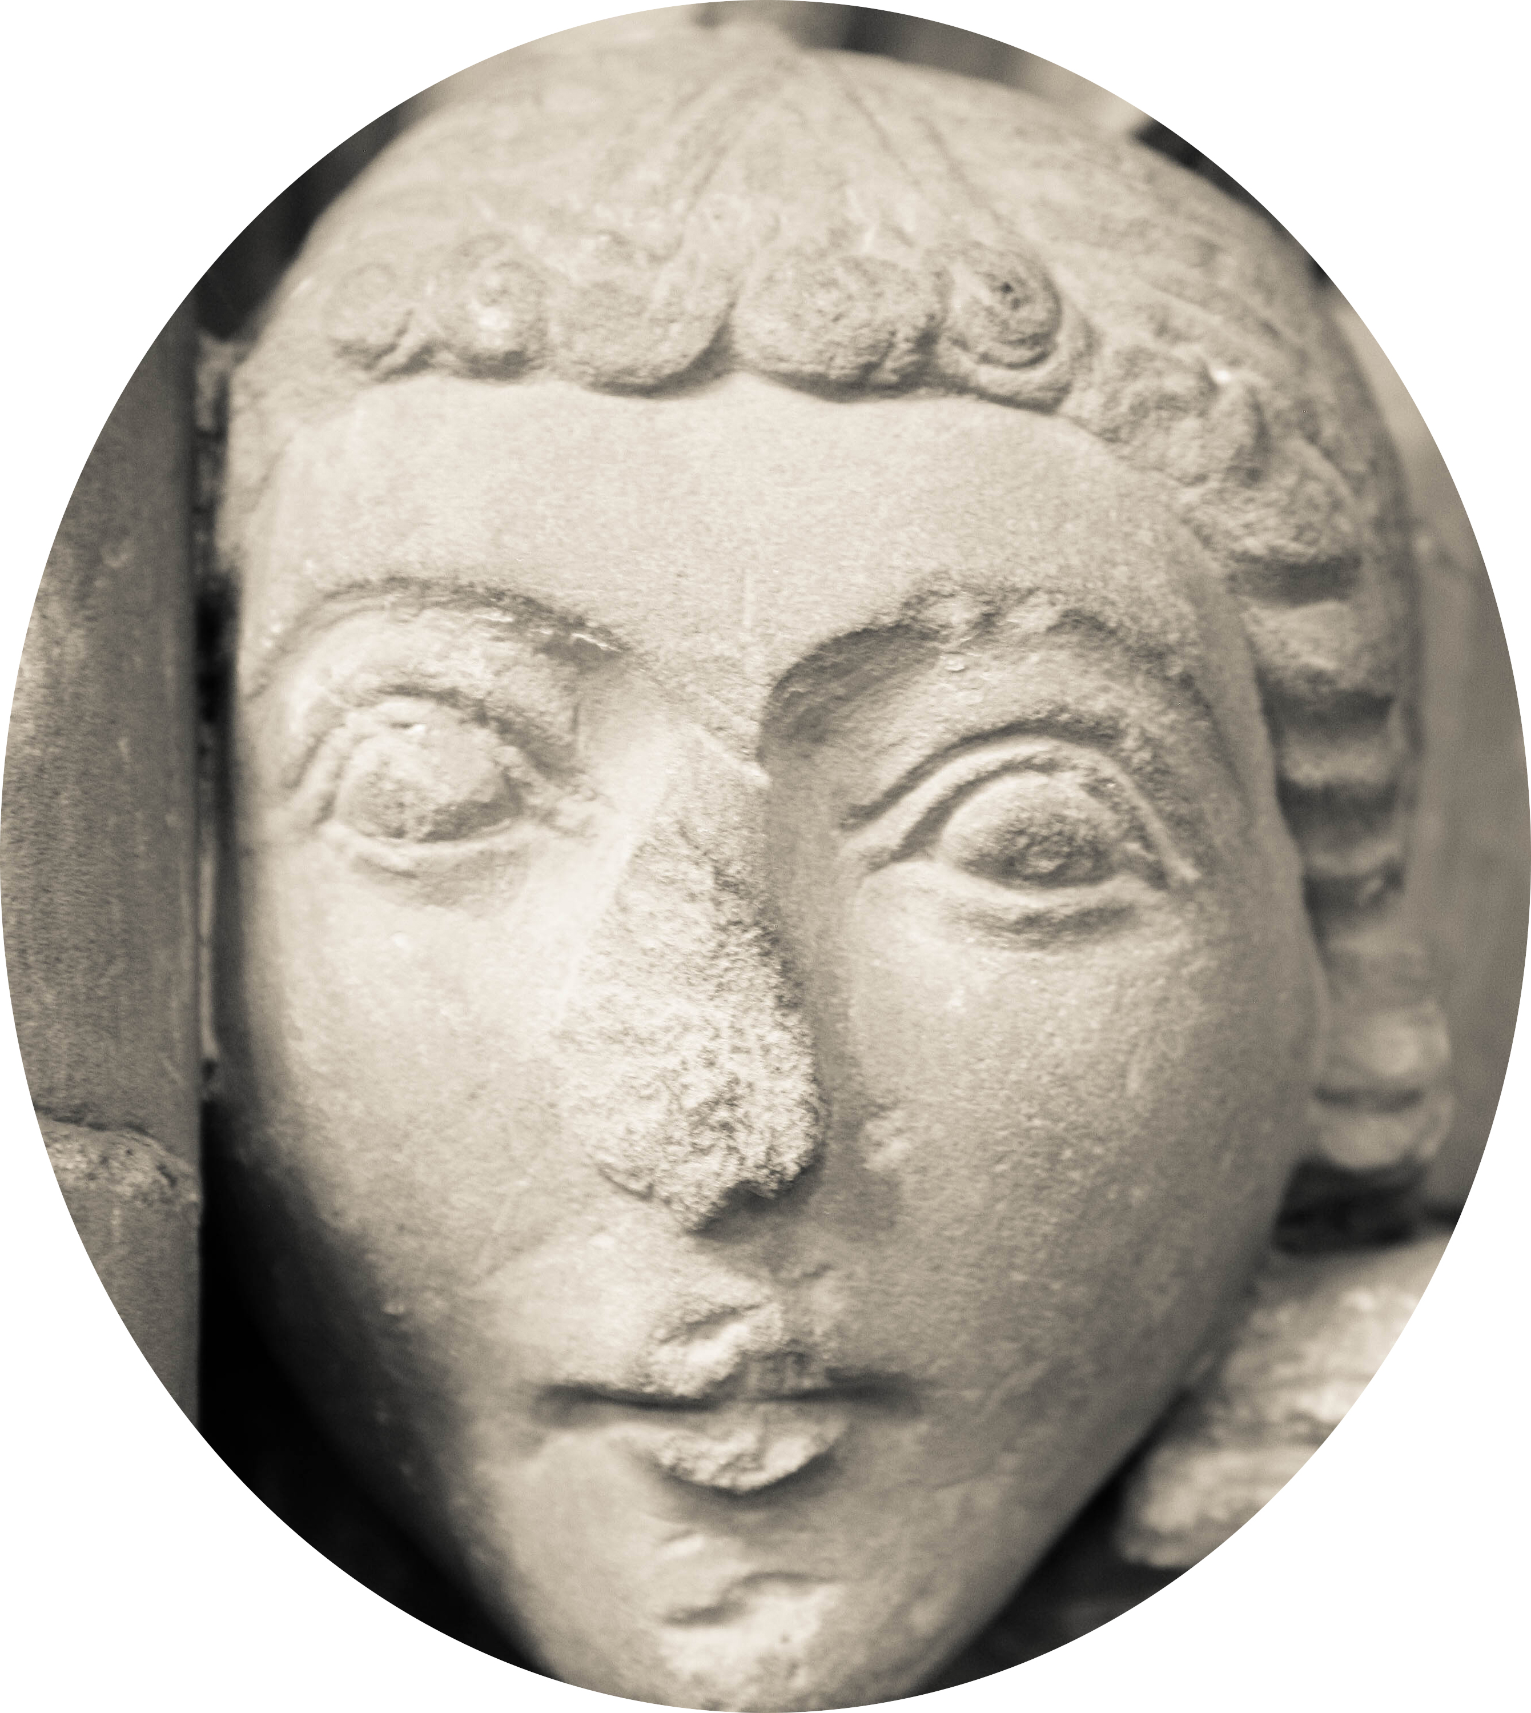
6755 E. Villanova Place. Denver, CO 80226 Phone: 480-235-1291
E-Mail: alexaoverby@gmail.com Web: alexandramoverby.weebly.com

CURRICULUM VITAE

Education
2011 Ph.D., Art Education, Curriculum and Instruction, Arizona State University, Tempe, AZ

2000 M.Ed, Curriculum and Instruction, Arizona State University, Tempe, AZ

1998 B.F.A., Art Education, Arizona State University, Tempe, AZ

Experience
2018 to present Adjunct Graduate Instructor, Art of Education University, https://theartofeducation.edu/ , Osage, IA

2018 to present Adjunct Graduate Instructor, University of Denver, Denver, CO

2016 to present Senior Team Lead, East High School, Denver, CO

2014 to present Regional Team Specialist/District Team Lead for Visual Arts

2014 to present Visual Art Educator, East High School, Denver, CO

2013 to 2014 Visual Art Educator, Abraham Lincoln High School, Denver, CO

2012 - 2013 Assistant Professor of Art Education, Alabama A&M University, Huntsville, AL

2000 - 2012 Art Teacher, Gilbert High School, Gilbert, AZ (leave of absence, 8/2009 to 7/2010)

2008, 2010 Instructor, ARA 311 Art Appreciation and Human Development, Arizona State University

2008 -2012 Art Masterpiece parent volunteer, curriculum designer

2009, 2007 Teaching Assistant, Children’s Art Workshop, Arizona State University

2004-2009 Visual Arts Department Head, Gilbert High School, Gilbert, AZ

2001-2004 Art Teacher, Summer Art Academy, Gilbert, AZ

1999-2000 Art Teacher, Tempe High School, Tempe, AZ

1998-1999 Art Teacher, Desert Vista High School, Phoenix, AZ

Dissertation
Reflective Photographic Practice: Developing Socially Contextualized Student Photographers

This study argues that traditional photography courses for secondary students, which focus on teaching technical skills, should be altered to use student interests and historical contexts in order to create socially engaged students. A new approach to the photography curriculum was developed that uses a thematic approach to the course. Working collaboratively, the students and teacher-researcher examined topics such as teenage stereotypes and family by researching the images, history, and cultural context of these themes. The students then created images based on these ideas and wrote reflective statements about their work. Throughout the semester, the students and teacher-researcher dialogued about the course and refined the curriculum as needed. The conclusions from this study defend the need to redefine typical art course curriculum by including relevant thematic issues as well as including historical context to the students’ learning.

Publications
2015 “Virtual Legos: Using Minecraft in the Art Education Classroom” with Dr. B. Jones, Art Education, January 2015

2011 "The Class Critique: Get Beginning Art Students to Talk About Art," Arts and Activities, January 2011

2011 Reflective Photographic Practice: Developing Socially Contextualized Student Photographer, Dissertation, Arizona State University,229 pages; 3453512

2009 “Visualizing Music”. November 2009, SchoolArts

2009 “The New Conversation: Using Weblogs for Reflective Practice in the Studio Art Classroom”, July 2009, Art Education Journal

2006 “Arizona Visual Arts Redesign”, committee member on panel

2005 “I Am Your Child’s Teacher”, Radio Essay on KJZZ /NPR 91.5

2004 “Gilbert Public Schools Photography Alignment and Standards”, with R. Guignard and R. Smith, art teachers.

Presentations

November 2018 “AP Art History Roundtable”, Colorado Art Education Association Conference, Breckenridge, CO

November 2018 “Art of Play in Photography”, Colorado Art Education Association Conference, Breckenridge, CO

November 2017 “Photography Roundtable”, Colorado Art Education Association Conference, Breckenridge, CO

March 2017 “Differentiation in the Digital Art Classroom” National Art Education Association Conference, New York, NY

November 2016 “Photography Roundtable”, Colorado Art Education Association Conference, Breckenridge, CO

November 2015 “Photography Roundtable”, Colorado Art Education Association Conference, Breckenridge, CO

“Photo Walk”, Colorado Art Education Association Conference, Breckenridge, CO

“Incorporating Art History”, Colorado Art Education Association Conference, Breckenridge, CO

November 2014 “Teaching Photography in the 21st Century”, Colorado Art Education Association Conference, Breckenridge, CO.

November 2014 “Power of the Post-it Note: Engaging Students in Reflection and Language in the Art Room” Colorado Art Education Association Conference, Breckenridge, CO.

March 2014 “Virtual Legos” with Dr. Brian L. Jones, National Art Education Association Convention, San Diego, CA.

March 2014 “Teacher as Researcher” with Hillary Andrelchik, National Art Education Association Convention, San Diego, CA.

March 2014 “Social Media in the Art Classroom”, National Art Education Association Convention, San Diego, CA.

March 2013 “Voices From the Trenches: Art Educators Speak Out”, National Art Education Association Convention, Forth Worth, TX.

March 2013 “School Art Takes Over Downtown; How one school district runs a public Art Walk”, National Art Education Association Convention, Forth Worth, TX.

March 2013 “Cinderella, Plato, and Darwin-Oh My! Using Text to Inspire Student Art”, National Art Education Association Convention, Forth Worth, TX.

March 2011 “Reflective Photographic Practice: Developing Socially Contextualized Student Photographers,” National Art Education Association Convention, Seattle, WA.

March 2011 “Why Are You Teaching That? The Importance of Publishing Contemporary Education Research”, Society for Photographic Education Conference, Atlanta, GA, panel presentation with William Nieberding, Ohio State University, and Keith Shapiro, Penn State

January 2011 “The Way We See It: Giving Adolescents Voice in the Traditional Photography Class,” Art and Design For Social Justice Symposium, Florida State University, Tallahassee, FL.

January 2011 “Breaking Away; A Pre-Service Art Teacher’s Reflection on Becoming a Teacher (Documentary Video), Narrative, Arts-Based, and Post-Approaches to Social Research Conference, Arizona State University, Tempe, AZ, presented as part of Dr. Eric Margolis, Arizona State, Visual Research Workshop

October 2010 “The Way We See It: Adolescent Photographers In the Digital Age,” Society for Photographic Educators Southwest Regional Conference, Prescott, AZ.

September 2010 “Re-Imaging; Using Old Photographs to Create New Works of Art”, hands-on workshop, Arizona Art Education Association Conference, Tempe, AZ.

July 2010 “Breaking Away; A Pre-Service Art Teacher’s Reflection on Becoming a Teacher “, Documentary Video presented at International Visual Sociology Association Conference, Bologna, Italy.

April 2010 “There is no wrong answer in art: A qualitative study of Art Masterpiece volunteers in a suburban Phoenix elementary school,” Featured Paper, ArtsWork Symposium, Arizona State University, Tempe, AZ

April 2010 “A Semiotic Study of Stereotypical Images of Art Teachers in Genre School Films”, Poster Presentation, National Art Education Association Convention, Baltimore, MD.

July 2009 “The Struggle for Ownership of Teacher Space in a Secondary School”, International Visual Sociology Association Conference, Cumbria, UK.

April 2009 “The New Conversation: Using Weblogs for Reflective Practice in the Studio Art Classroom”, National Art Education Association Conference, Minneapolis, MN.

April 2009 “The New Conversation: Using Weblogs for Reflective Practice in the Studio Art Classroom”, poster presentation, ARTSWORK symposium, Arizona State University, Tempe, AZ.

October 2008 “Reflective Practice in the Studio Art Classroom”, hands-on workshop, Arizona Art Education Association Conference, Prescott, AZ.

October 2005 “A Study of Nature as an Art Form”, hands-on workshop, Arizona Art Education Association Conference, Phoenix, AZ, presented with Ida Gaumitz, art teacher

October 2004 “A Study of Nature as an Art Form”, hands-on workshop, Arizona Art Education Association Conference, Tucson, AZ, presented with Ida Gaumitz, art teacher

October 2003 “Low-Tech Transfers”, hands-on workshop, Arizona Art Education Association Conference, Sedona, AZ

October 2002 “Cyanotypes”, hands-on workshop, Arizona Art Education Association Conference, Prescott, AZ 2002

Art Shows
2018 CAEA Teachers’ Show, Arapahoe Community College, Littleton, CO

2017 Magnificent Works, CAEA Traveling Exhibit, Colorado

2016 Radical Compliance, CAEA Exhibit, Center for Visual Arts, Denver, CO

2015-2016 A Circular Exploration, CAEA Traveling Exhibit, Colorado

2015 The Big Picture, Month of Photography Show, Denver, CO

2014-2015 Expanding the Possibilities, CAEA Traveling Exhibit, Colorado

Community Work
2019 Coordinator of DPS Student Photo Show, Denver, CO

2015 to present Coordinator/Organizer of Denver High School Month of Photography Show

2013 Panoply Arts Festival – Huntsville, AL (art activities for children)

2013 Head of New Visions High School Art Show, Alabama A&M Art Gallery

2013 Volunteer Art Educator, Montessori Learning Center, Huntsville, AL

2011 -2012 HS Photography Show Coordinator, Art intersection Gallery, Gilbert, AZ

2011-2012 ArtsWalk Coordinator, Gilbert, AZ

2010 Designed website and Curriculum for The Ziz (City of Goodyear, AZ)

Awards and Grants
2018 Colorado High School Art Educator of the Year (Colorado Art Education Association)

2017 National Board Teacher Certification

2013 Video feature “Picture Perfect” on ALHS photo program for Denver Public Schools Communication Department

2013 Awarded National Art Education Foundation grant for technology work with teachers

2009, 2010 Presenter at ARTSWORK symposium, Arizona State University, Tempe, AZ

2005 Teacher of the Month, Gilbert High School, Gilbert, AZ

2003, 2004 Grant, Gilbert Education Foundation, “Photography Field Trip for Landscape Unit”

Fall 2002 Grant, Wells Fargo Bank, Photography Field Trip

Fall 2001 Grant, Wells Fargo Bank, Restoration of Darkroom Equipment

Professional Memberships
- National Art Education Association
- Colorado Art Education Association
- Colorado Education Association

Professional Activity
2016 to present Colorado Art Education Association Collage Editor (magazine)

2014 to 2016 Colorado Art Education Association High School Representative

2012 Arizona Art Educator Association Pre-Service Art Teacher Group Coordinator

2012 Arizona Art Educator Association Liaison to Arizona Alliance to Arts Education

2010 - 2012 Guest Speaker at Arizona State University – Art Education Classes

2003 - 2010, 2012 Volunteer, Arizona Art Educator Association Conference Committee

2008, 2011 Mentor Teacher for Student Collaboration Project with Art One Gallery

2005-2006 Committee Member, Visual Arts Standards Revision for State of Arizona

2005 – 2009 AIMS Recognition Committee Chair, Student Involvement Committee, Gilbert High School, Gilbert, AZ

2002 – 2008 Vice-President and Webmaster, Winterguard Arizona

2003 – 2008 Judge, Winterguard Arizona

Courses Taught - University
ARA 311 Art Appreciation and Human Development
ART 101 Art Appreciation
ART 300 Teaching Art in Elementary School (Elementary Pre-Service course)
ART 310 Teaching Methods for Elementary School
ART 410 Teaching Methods for Secondary School
ART 495 Student Teaching Internship
ART 500 History and Philosophy of Art Education
ART 522 Independent Study
ART 532 Issues and Trends in Teaching and Supervision
ART 534 Art in Childhood Education
ART 538 Workshop in Curriculum Development
ART 595 Student Teaching Internship

Courses Taught – High School
Advanced Placement Art History
Advanced Placement Studio Art: 2D
Digital Photography – 3 levels
Analog Photography – 4 levels
Drawing & Painting – Beginning and Intermediate
Art Survey/General Art
Ceramics
Digital Art

General Research and Teaching Interests
- Incorporating Technology in Studio Art Courses
- Photography Education
- Social Justice
- Pre-service Art Educator training
- Meaning Making in Student Art Work
- Visual Culture

Other Experience
- K-12 certified teacher for State of Colorado and State of Arizona
- Career and Technical Endorsement (Colorado and Arizona)
- SEI/ELA Endorsement
- Volunteer for Gilbert ArtWalk Event (2010-13)
- Photography students earned multiple accolades for their artwork, including local, state, national, and international competitions
- Colorguard/Dance coach for high school and college groups

References
Craig Ackley
Visual Art Department Chair
East High School
craig_ackley@dpsk12.org
720-423-8300

Barth Quenzer
Visual Art Coordinator
Denver Public Schools
barth_quenzer@dpsk12.org

Dr. Bernard Young
Professor of Art Education
Herberger Institute for Design and the Arts
School of Art
Arizona State University
PO Box 871505
Tempe, AZ 85287-1505
bernard.young@asu.edu
480.965.3341

Dr. Eric Margolis
Professor of Communications and Education
The Hugh Downs School of Human Communication
Arizona State University
PO Box 871205
Tempe, AZ 85287-1205
eric.margolis@asu.edu
480.965.0131

Scott Smith
Associate Professor of Art, Program Director
Department of Visual, Performing, and Communication Arts
Alabama A&M University
4900 Meridian Street North
Normal, AL 35810 - 1015
256.372.4073
scott.smith@aamu.edu

